Chapter 4, Problem 74.

For the bridge circuit shown in Fig. 4.140, find the load R_{L} for maximum power transfer and the maximum power absorbed by the load.

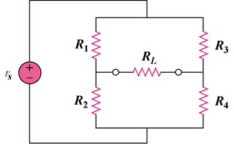

Figure 4.140
For Prob. 4.74.

